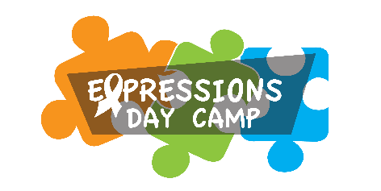

These leaders give us a cool vibe in our tribe!

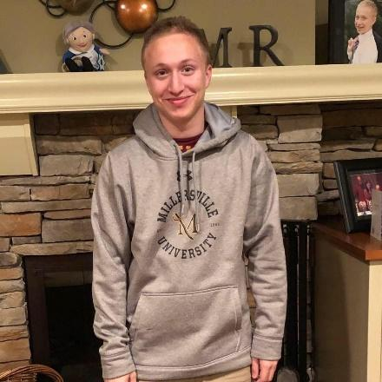
GUMMY BEARS- MAX LEVINE 7th summer
Hello Expressions families! My name is Max Levine, and I am one of the lead counselors for the Gummy Bears group. This is my seventh summer working for Expressions having started after my freshman year of high school and just having finished up my junior year at Millersville University in Lancaster. I am a dual major in early childhood and special education and have a huge passion for working with kids. Outside of camp I have a passion for video games, movies, TV, and music and love talking about each of those things endlessly! I am so beyond excited for another memorable summer with Expressions and hope to do the best to make sure everybody has the best summer ever!
Check out my welcome video here
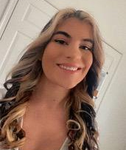
GUMMY BEARS- CAITLYN KELINTOP 1st summer
Hi everyone! My name is Caitlyn and this is actually my first year working for Camp Concepts in the Expressions Day camp. I will be working with the Gummy Bears and I could not be more excited to meet every single one of you! I am a Junior at Penn State studying Communication Sciences and Disorders on a Speech Language Pathology track with a minor in Equine Science. In my free time I love to go horseback riding and showjumping at my barn and spend most of my time outside or with my dog. During the School year I did work for Penn State Equine Barns and Research Team and also the Speech and Hearing Clinics. My dream job would be to get my degree in Speech Language Pathology and become an Equine Facilitated Therapist or work in Elementary Schools. I can’t wait to make so many lasting memories and friendships this summer!
Check out my welcome video here

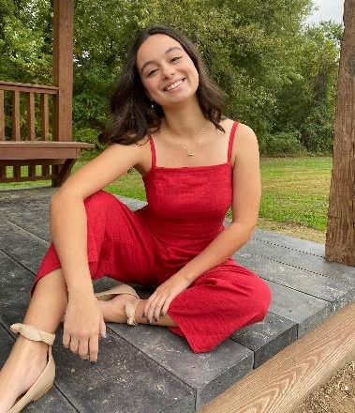
GUMMY BEARS- EMMA TIERNEY 4th summer
Hi! My name is Emma Tierney, and this is my 4th year working as a Lead Counselor for the Expressions Day Camp – Gummy Bears Group. I just completed my freshman year at Duquesne University where I am studying Occupational Therapy. I am excited to return to Expressions Day Camp because I love meeting campers, helping them make friends and have fun in all the activities we offer. This year I will be leading some of those great activities as well as leading some social skills groups.
I am looking forward to all of the fun summer activities and especially the end-of-summer CAMPER SHOWCASE!
Check out my welcome video here

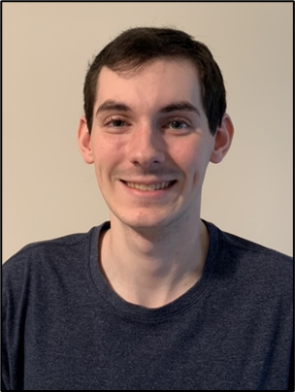
SKITTLES- ZACH LUCAS 5th summer
My name is Zachary Lucas, and I am very excited to be starting my 5th year as a Lead Counselor at Expressions Day Camp. In 2021, I successfully completed my Associates Degree in Chemistry from Bucks County Community College. Currently, I attend Rider University where I am a dual major of Secondary Education and Chemistry. I bring with me three years’ experience as a CIT from KidsCamp of Pennsbury. I have also earned my 3rd degree black belt in karate from Action Karate Newtown where I have been a student for 11 years. In my free time, I like spending time with my friends, watching and playing sports, and playing video games. I’m looking forward to another great year with Expressions Day Camp!
Check out my welcome video here
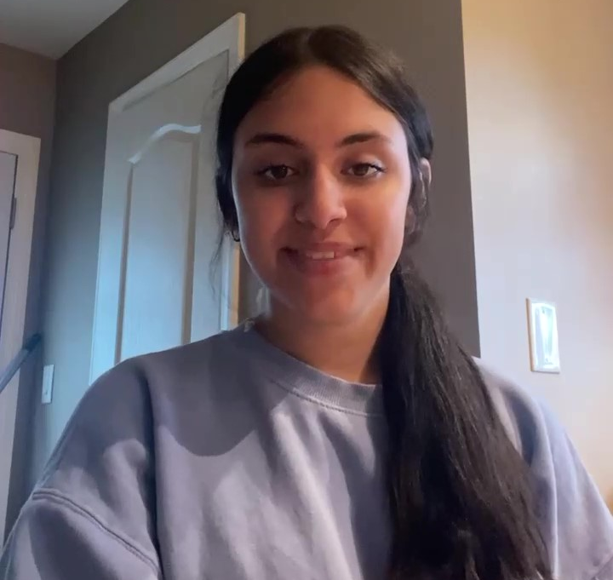
SKITTLES -Gianna Santoro 1st summer
Hi everyone! My name is Gianna, I am going into my sophomore year at Sacred Heart University. I am a Psychology major on the Occupational Therapy track. This is my first year here at camp, so I am so excited to meet everyone and can’t wait for all of the opportunities camp could bring. I love spending time outside, especially at the beach, hanging out with friends and family, and playing with my dog Bentley. I can’t wait to meet everyone and am so looking forward to having a great summer together!!
Check out my welcome video here

