BIG OAK DAY CAMP

LEAD COUNSELORS

HELPING CAMPERS TO SHINE

RAZZLEBERRIES (6 Year olds) - EMMA

Hi Razzleberries! My name is Emma Hitchingham, and this is my fourth summer on the staff of Camp Concepts. My first 2 summers were spent with the Little Buds, and last year I was the counselor for the 6- and 7-year-olds. I am excited to be joining the staff of Big Oak again this summer; as the counselor for the Razzleberries, 6-year-olds, this summer! In May, I graduated with my associate degree in Early Childhood Education from Bucks County Community College, and in the Fall, I will be attending Holy Family University to complete my bachelor’s degree in Elementary Education. During the school year, I worked as a full-time kindergarten assistant teacher at a local preschool. In the evenings, I teach dance at BC Discoveries Dance and Theater Arts Company. I teach various styles of dance and conditioning to students ranging in age from 2 to 16 years old. For fun, I enjoy spending time outside, crafting, and getting coffee with my friends. I am excited for another fun-filled summer at Big Oak Day Camp.

View Emma’s welcome video: <https://youtu.be/lcv74MBmwn0>

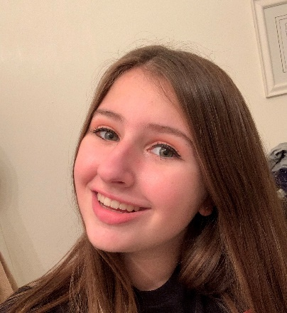STEAMROLLERS (7 Year olds) - MIA

Hi Steamrollers! My name is Mia Guglietta, and I am super excited to be returning to Big Oak Day Camp this Summer!

I just recently graduated from Pennsbury High School, and in the fall, I will be beginning my college journey as a Film/Television Major at DePaul University in Chicago, Illinois.

I have been with Camp Concepts since I was 6 years old; I love working with kids and cannot wait to meet all of you soon! Outside of camp I am a dancer and I love hanging out with friends and family (and my dog)! I am beyond excited to make this an unforgettable Summer! View Mia’s welcome video: : <https://youtu.be/6LwtQhtKI4c>

TRAILBLAZERS (8 Year olds) - KOBE

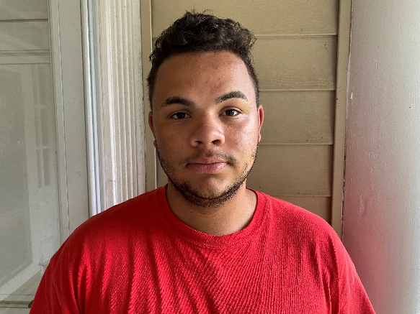Hello Trailblazers and parents! My name is Kobe Cash, and I am so excited to be a part of camp this summer. A little bit about myself, I was born and raised in Yardley, PA and I have truly enjoyed being a apart of such a great community. I graduated high school in 2020 from Calvary Christian Academy and currently attend Liberty University, where I am a nursing major. From a young age I have always had a passion for helping others and an interest in medicine. My dream job would be to work in a post-traumatic rehabilitation center. Another passion of mine is sports. I have been skiing and playing soccer my entire life.  Growing up playing soccer taught me the importance of needing good communication and teamwork.  I truly am so excited to get to know all of you and make this the best summer ever!

View Kobe’s welcome video: <https://youtu.be/NE_8shTF0_0>

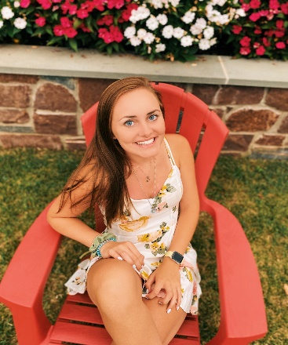DREAMWEAVERS (9 Year olds) - BRIANNA

Hi Dreamweavers! My name is Brianna Palmer, and this is my first year at Camp Concepts! I am a rising junior at Monmouth University in Long Branch, NJ where I am a Political Science/Legal Studies Major! I hope to go on to law school after I graduate from Monmouth. Outside of school I also work as an after school teacher/coach. I work with kids grades 6-8, helping them out with homework and running athletic clubs such as Flag Football and Soccer. In my free time I love staying active, working out, playing sports, and going to the beach! I have always enjoyed sports and was captain of three varsity teams in high school including basketball, soccer, and softball. I am so excited to be a part of this team and I can’t wait to make so many amazing memories this summer!

View Brianna’s welcome video: <https://www.youtube.com/watch?v=jlws-jtCV-g>

STARBURSTS (10/11 Year olds) - BEN

Hi Starbursts! My name is Ben Spadea and I am super excited to be a member of the Camp Concepts team! This is my first time here at camp and I look forward to all the fun competitions that we’ll get to participate in this summer! A little about myself; I have just graduated from Cairn University with a BA in History/ Arts with a minor in Education. I chose this major to fulfill my love of art, literature and culture while also preparing myself for my future career of teaching and coaching. I’ve grown up loving art, music, and literature as well as anything that resembles a sport. When I wasn’t sketching or writing you could find me on the baseball diamond, track, or basketball court. I have a natural gravitation towards any kind of sport, and nothing makes me more excited than seeing kids give their best and enjoy some good-hearted competition and fun. During my four years playing collegiate baseball for my university, I’ve come to understand the importance of perseverance and teamwork on a much larger scale. Being named a Captain my junior year allowed me to really mentor my peers and push them to be the best versions of themselves. To me there is no better feeling than watching your peers succeed and enjoy doing so. Whether you’re a pro or brand new to a game, it’s all about having a good time and building up your peers! I’m so excited to meet everyone and hopefully I can make this experience as fun as possible and help each camper grow in their love for games and sports! My main goal is to show each camper that I’m ready to have fun and make this experience as awesome as it’s designed to be. I beg you, please feel free to come right up to me as I love talking and meeting new people. I will NEVER pass on the opportunity to make a new friend. There isn’t a single game/sport/tv show or song that I won’t talk about! Some of my miscellaneous talents/interests include magic, rubix cube enthusiast, and a love for animated movies! My only concern is I hope each camper is ready to have as much fun as me!! Let’s have some fun!!

View Ben’s welcome video: <https://youtu.be/S_GGgEkLcUY>

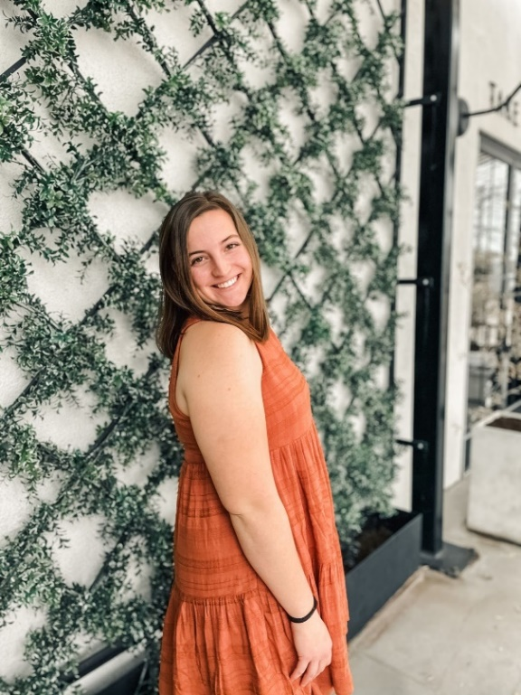FIREBALLS (12-14 Year olds) – ERIN

Hi Fireballs! My name is Erin Haines, and I am happy to serve as your counselor this year! I am a rising junior at Messiah University in Mechanicsburg, PA studying Elementary Education and Teaching English as a Second Language. This will be my seventh year working at camp! Some of my hobbies are traveling, cycling, weightlifting, and drinking lots of coffee. A fun fact about me is I am the first camper to ever register for Little Buds Day Camp! I have participated in sports and camp my whole life and always look forward to the wonderful experiences camp can bring to me and my campers this summer!

View Erin’s welcome video: <https://youtu.be/K8ZmvS7L1gA?list=PLSVW3PUm>